**Coding Assignment**

1. Build and Train a neural network using Genetic Algorithm to realise the functionality of XOR gate.

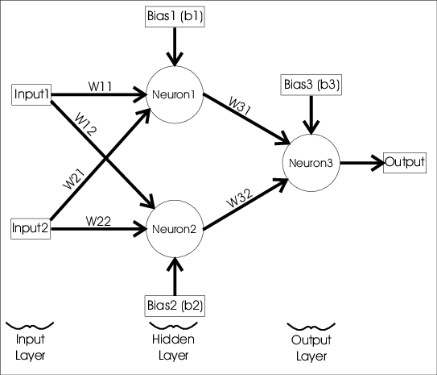

To start evolving the **GA,** the **run()** method is called. This method applies the pipeline of the genetic algorithm by calculating the fitness values of the solutions, selecting the parents, mating the parents by applying the mutation and crossover operations, and producing a new population.

This process lasts for the 50 generations.

Assume the following:

1. Each chromosome represents all the weights in the network.
2. Initial random population of 10 members
3. Accuracy measure is used as fitness function.
4. Initial biases
5. Activation functions as either Sigmoid or Relu for input and hidden layers. You may choose softmax for output layer.
6. Use appropriate GA Operators: Crossover, Mutation

**Note :** Implementation should be done using appropriate libraries in Python